
School of Computer Science and Engineering
B.Tech Computer Science and Information Technology

Course Code: B22EJ0601 |  | Big Data Analytics Lab Project Report | Academic Year: 2025-26
 |  |  | Semester & Batch: VI
Project Details:
Project Title: | HEALTHCARE BILLING ANALYSIS
Place of Project: | REVA UNIVERSITY, BENGALURU
Student Details:
Name: | S SRUTHI  M UDAY SHANKAR |  | Sign:
Mobile No: | 9591385998  6301159579
Email-ID: | 23010800387@reva.edu.in  23010080345@reva.edu.in
SRN: | R23EJ165  R23EJ152
Guide and Lab Faculty Members Details
Guide Name |  |  | Sign:  Date:
Grade by Guide:
Name of Lab Co- Faculty 1 |  |  | Sign:  Date:
Grade by Lab Faculty Members
SEE Examiners
Name of Examiner 1: |  | Sign:  Date:
Name of  Examiner 2: |  | Sign:  Date:

Contents
1 Abstract  - Introduction  - Literature Review  - Methodology  - Results and Discussion  - Conclusions  - References  - Appendices | 3  4  5  6  8  10  11  12

Abstract

The Healthcare Billing Analysis and Cost Prediction System is designed to analyze healthcare data and provide meaningful insights into billing patterns, insurance claims, and patient-related factors. This project utilizes data visualization and machine learning techniques to enhance understanding of healthcare expenses and improve decision-making.

The system processes a dataset containing patient details such as medical conditions, admission types, billing amounts, insurance providers, and claim statuses. Using Python-based tools, the data is analyzed to generate key metrics like total revenue, claim approval rate, and average length of hospital stay. Interactive visualizations, including bar charts, pie charts, histograms, and scatter plots, are used to represent trends and patterns effectively.

In addition to analysis, the system incorporates a machine learning model to predict treatment costs based on inputs such as medical condition, admission type, and duration of stay. This predictive feature helps estimate future healthcare expenses and supports better financial planning.

The application is implemented using Streamlit to provide an interactive dashboard interface, enabling users to filter data and explore insights dynamically. Overall, the project demonstrates how data analytics and machine learning can be applied in the healthcare domain to improve transparency, optimize costs, and support informed decision-making.

2. Introduction

Healthcare systems generate a large amount of data related to patient records, treatments, billing, and insurance claims. Analyzing this data is essential for understanding cost patterns, improving operational efficiency, and supporting better financial and medical decision-making. However, raw healthcare data is often complex and difficult to interpret without proper analytical tools.

This project, Healthcare Billing Analysis and Cost Prediction System, aims to transform raw healthcare billing data into meaningful insights through data analysis, visualization, and machine learning techniques. The system focuses on key aspects such as billing amounts, insurance provider contributions, claim approval rates, and patient-related factors like medical conditions and length of hospital stay.

Using Python and data visualization libraries, the project presents interactive dashboards that help users explore trends and patterns in healthcare costs. Additionally, a machine learning model is implemented to predict treatment costs based on inputs such as disease type, admission type, and duration of stay, enabling users to estimate future expenses.

The application is developed using Streamlit, providing a user-friendly interface where users can filter data, view graphical insights, and interact with predictive features. Overall, this project demonstrates the practical application of data analytics and machine learning in the healthcare domain to improve cost transparency, enhance decision-making, and support efficient resource management

3. Literature Review

- The application of data analytics and machine learning in the healthcare domain has gained significant attention in recent years. Researchers have explored various methods to analyze healthcare data for improving cost efficiency, patient care, and operational management.

- Several studies have focused on healthcare billing analysis to identify patterns in medical expenses and insurance claims. Traditional statistical methods have been used to examine factors influencing hospital costs, such as length of stay, type of treatment, and patient demographics. These studies highlight that chronic diseases and emergency admissions often lead to higher healthcare expenditures.

- With the advancement of technology, machine learning techniques have been widely adopted to enhance predictive capabilities in healthcare. Algorithms such as decision trees, random forests, and regression models have been used to predict medical costs, detect fraudulent insurance claims, and improve claim approval processes. These models provide better accuracy and scalability compared to conventional methods.
- Data visualization tools have also played a crucial role in healthcare analytics. Interactive dashboards enable users to explore complex datasets through charts and graphs, making it easier to interpret trends and insights. Platforms like Streamlit and Power BI have been commonly used to build user-friendly interfaces for real-time data analysis.

- Furthermore, big data frameworks such as Apache Spark have been introduced to handle large-scale healthcare datasets efficiently. Spark enables faster data processing and supports advanced analytics, making it suitable for large healthcare systems. However, for moderate-sized datasets, lightweight tools like Pandas are often preferred due to their simplicity and faster execution in interactive applications.

- Overall, the existing literature emphasizes the importance of integrating data analytics, visualization, and machine learning to improve healthcare cost management and decision-making. This project builds upon these concepts by combining analytical techniques with an interactive dashboard and predictive model to provide a comprehensive healthcare billing analysis system.
4. Methodology

The Healthcare Billing Analysis and Cost Prediction System is developed using a systematic approach that involves data collection, preprocessing, analysis, visualization, and predictive modeling. The methodology followed in this project is described below:

1. Data Collection
The dataset used in this project is obtained from an open-source platform and contains healthcare-related information such as patient details, medical conditions, billing amounts, insurance providers, admission types, and claim statuses. This data serves as the foundation for analysis and prediction.

2. Data Preprocessing
Before analysis, the dataset is cleaned and prepared to ensure accuracy and consistency. This includes:
- Handling missing or inconsistent values
- Converting data types (e.g., dates, numerical values)
- Renaming columns for easier processing
- Encoding categorical variables for machine learning

3. Exploratory Data Analysis (EDA)
Exploratory analysis is performed to understand the structure and patterns within the data. Key metrics such as total revenue, claim approval rate, and average length of stay are calculated. This step helps identify trends, anomalies, and relationships between different variables.

4. Data Visualization
Various visualization techniques are used to present insights in an understandable manner. These include:
- Bar charts for comparing revenue across insurance providers
- Pie charts for claim status distribution
- Histograms for analyzing numerical distributions
- Scatter plots to study relationships between variables
The visualizations are integrated into an interactive dashboard using Streamlit.

5. Machine Learning Model
A machine learning model is developed to predict treatment costs based on input features such as medical condition, admission type, and length of stay. The steps include:
- Selecting relevant features
- Converting categorical variables using encoding techniques
- Splitting data into input (X) and output (y)
- Training a regression model (Random Forest Regressor)
- Using the trained model to make predictions

6. Model Integration
The trained model is integrated into the Streamlit application, allowing users to input parameters and receive real-time cost predictions. This enhances the practical usability of the system.

7. Dashboard Development
An interactive dashboard is developed using Streamlit to:
- Display key performance indicators (KPIs)
- Provide filtering options
- Show dynamic visualizations
- Enable prediction functionality

8. Recommendation Generation
Based on analysis results, the system provides simple recommendations such as improving claim approval processes, reducing high treatment costs, and optimizing payment collection strategies.

5. Results and Discussions
5.1 Results
The Healthcare Billing Analysis and Cost Prediction System was successfully implemented and evaluated using the dataset. The system provides insights through dataset exploration, visualization, predictive modeling, and recommendations.
1.Revenue Analysis by Insurance Provider
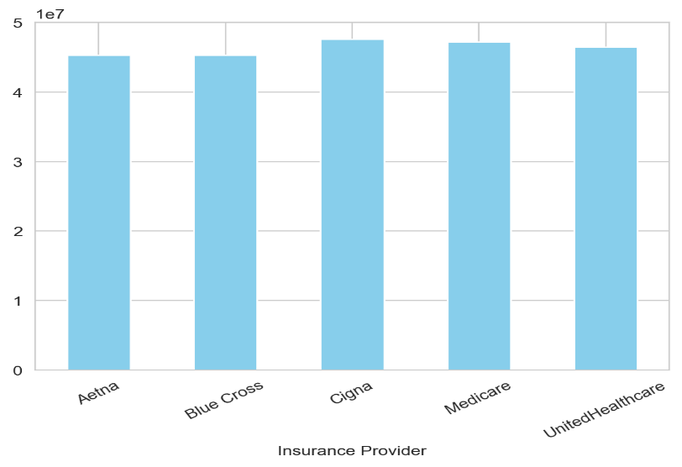
2. Claim Status Analysis
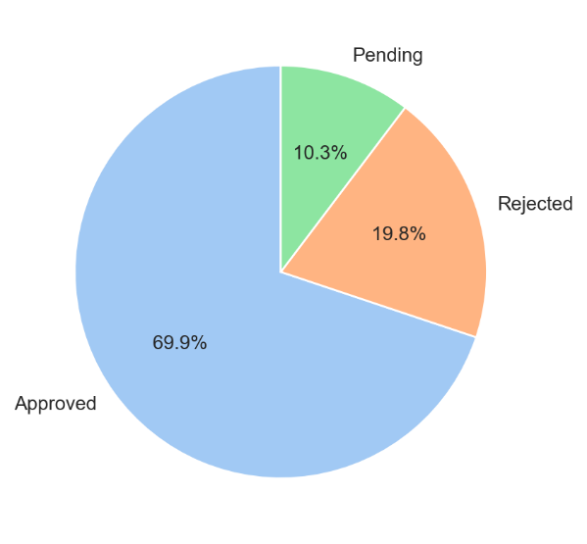

4.Length of Stay Analysis 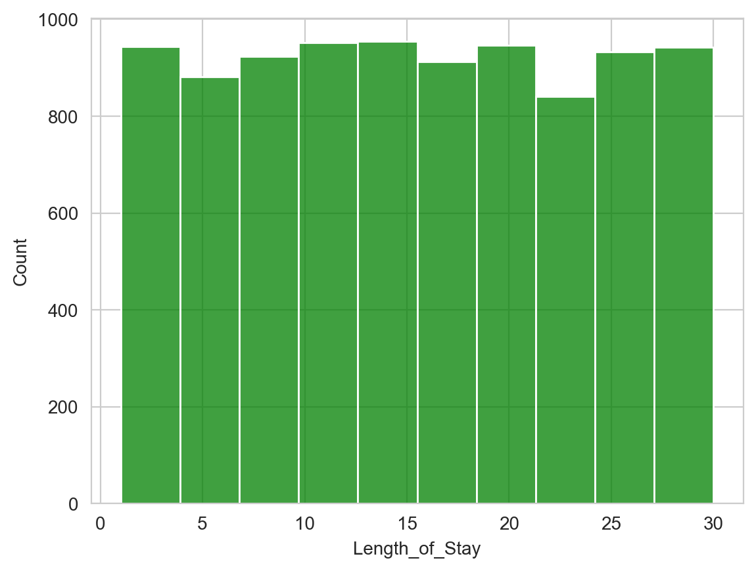
4. Billing Amount Distribution
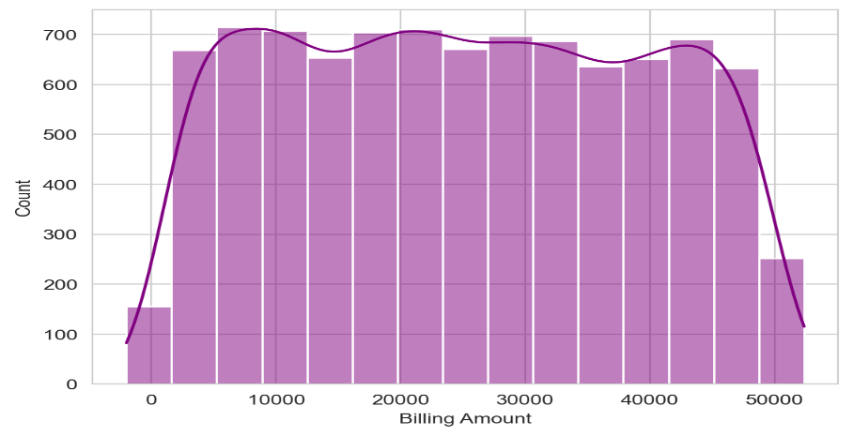
5. Relationship Between Length of Stay and Billing Amount
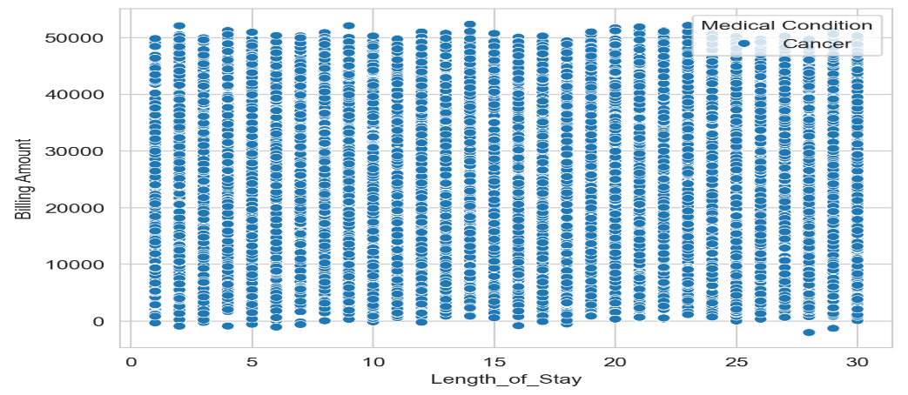

6. Conclusions
- The Healthcare Billing Analysis and Cost Prediction System was successfully developed to analyze healthcare data and generate meaningful insights. The system effectively processes patient and billing information to identify patterns related to revenue, insurance claims, medical conditions, and hospital stay duration.
- Through data visualization techniques, the project provides a clear understanding of key factors influencing healthcare costs. Charts and graphs such as bar charts, pie charts, histograms, and scatter plots help in identifying trends and relationships within the dataset. The analysis revealed that billing amounts are influenced by multiple factors, including length of stay, type of admission, and medical condition.
- The integration of a machine learning model further enhances the system by enabling cost prediction. Using inputs such as medical condition, admission type, and duration of stay, the model can estimate treatment costs with reasonable accuracy. This predictive capability makes the system useful for financial planning and decision-making.
- Additionally, the system provides recommendations to improve healthcare operations, such as reducing claim rejection rates, optimizing treatment costs, and improving payment collection processes. These insights can help healthcare providers enhance efficiency and reduce financial risks.
- In conclusion, the project demonstrates the effective application of data analytics and machine learning in the healthcare domain. It provides a comprehensive solution for analyzing billing data, predicting costs, and supporting informed decision-making, making it a valuable tool for both healthcare providers and patients.

7. References
- McKinney, W.
Data Structures for Statistical Computing in Python.
Proceedings of the 9th Python in Science Conference, 2010.
Link: https://pandas.pydata.org/docs/
- Pedregosa, F., et al.
Scikit-learn: Machine Learning in Python.
Journal of Machine Learning Research, 2011.
Link: https://scikit-learn.org/stable/
- Hunter, J. D.
Matplotlib: A 2D Graphics Environment.
Computing in Science & Engineering, 2007.
Link: https://matplotlib.org/stable/
- Waskom, M.
Seaborn: Statistical Data Visualization.
Python Library Documentation.
Link: https://seaborn.pydata.org/
- Streamlit Inc.
Streamlit Documentation.
Link: https://docs.streamlit.io/
- Breiman, L.
Random Forests.
Machine Learning Journal, 2001.
Link: https://link.springer.com/article/10.1023/A:1010933404324
- Han, J., Kamber, M., & Pei, J.
Data Mining: Concepts and Techniques.
Morgan Kaufmann Publishers, 2011.
- Healthcare Dataset Source
Healthcare Dataset (Kaggle).
Link: https://www.kaggle.com/datasets
- N. Marz and J. Warren, Big Data: Principles and Best Practices of Scalable Real-Time Data Systems, Manning Publications, 2015.
- T. White, Hadoop: The Definitive Guide, 4th ed., O’Reilly Media, 2015.
- H. Karau, A. Konwinski, P. Wendell, and M. Zaharia, Learning Spark: Lightning-Fast Big Data Analysis, O’Reilly Media, 2015.
- B. Chambers and M. Zaharia, Spark: The Definitive Guide, O’Reilly Media, 2018.
- Apache Spark Documentation, Available: https://spark.apache.org/docs/latest/
- PySpark Documentation, Available: https://spark.apache.org/docs/latest/api/python/
- Apache Hadoop Documentation, Available: https://hadoop.apache.org/docs/
- Streamlit Documentation, Available: https://docs.streamlit.io/
- J. Dean and S. Ghemawat, “MapReduce: Simplified Data Processing on Large Clusters,” Communications of the ACM, 2008.
- M. Chen, S. Mao, and Y. Liu, “Big Data: A Survey,” Mobile Networks and Applications, 2014.
- R. Kitchin, “The Data Revolution: Big Data, Open Data,” Sage Publications, 2014.
- J. Han, M. Kamber, and J. Pei, Data Mining: Concepts and Techniques, 3rd ed., Morgan Kaufmann, 2011.
- S. Raghupathi and V. Raghupathi, “Big Data Analytics in Healthcare,” Health Information Science and Systems, 2014.
- E. Shortliffe and J. Cimino, Biomedical Informatics: Computer Applications in Health Care, Springer, 2014.
- World Health Organization, “Global Health Data Reports,” Available: https://www.who.int
- Centers for Disease Control and Prevention, “Healthcare Data and Statistics,” Available: https://www.cdc.gov
- Kaggle, “Healthcare Datasets,” Available: https://www.kaggle.com/datasets
- UCI Machine Learning Repository, “Health Data Sets,” Available: https://archive.ics.uci.edu/ml
- A. Ahmed et al., “Predictive Analytics in Healthcare Using Machine Learning,” IEEE Access, 2021.
- S. Kumar and M. Singh, “Sentiment Analysis of Patient Reviews Using NLP,” Elsevier Journal of Healthcare Informatics, 2022.

